**VISUALIZATIONS: PANDAS & SEABORN**

**Introduction**  
Data visualization is the practice of transforming raw numbers and statistics into meaningful visual representations that communicate insights effectively. Python offers a robust ecosystem of libraries to support this, enabling everything from simple line charts to advanced interactive dashboards. Whether you are exploring a dataset for the first time, presenting insights to stakeholders, or developing a live data application, choosing the right visualization tool can significantly enhance clarity and impact.

This guide provides an overview of some of the most widely used Python visualization libraries, including **pandas** and **Seaborn**. It explains their strengths, key differences, and practical use cases. By the end, you will have a clear understanding of which library best suits your needs and how to begin creating compelling, data-driven visuals.

**PANDAS**

**Pandas** is a versatile Python library widely used for data manipulation, analysis, and visualization. It introduces two core data structures—**Series** (1D) and **DataFrame** (2D)—that make it easy to work with structured, tabular data.

While Pandas is primarily recognized for its powerful data cleaning, transformation, and analysis capabilities, it also provides built-in visualization methods. These allow users to quickly generate plots directly from Series or DataFrames, making Pandas especially valuable for **exploratory data analysis (EDA)**.

**Key Features of Pandas**

1. **Powerful Data Structures** – Provides **Series (1D)** and **DataFrame (2D)** for handling structured datasets.
2. **Flexible Data Manipulation** – Supports filtering, grouping, merging, joining, and reshaping data.
3. **Robust Handling of Missing Data** – Includes tools to detect, remove, or impute missing values.
4. **Seamless Data Import & Export** – Reads and writes multiple formats, including **CSV, Excel, JSON, and SQL databases**.
5. **Built-in Visualization** – Offers quick plotting directly from Series/DataFrames using .plot().
6. **Integration with Other Libraries** – Works efficiently with **NumPy, Matplotlib, and other data science libraries**.
7. **High Performance** – Optimized for large-scale datasets with efficient indexing and operations.

**GRAPH TYPES**:

Top of Form

**1. Line Plot**

**Description:** Plots data points connected by lines, showing trends over continuous data.  
**Use Case:** Sales growth over months.

**Sample Code:**

import pandas as pd

data = pd.Series([10, 20, 15, 25, 30])

data2  = pd.Series([12,22,17,27,32])

data.plot(title="Line Plot", marker='o')

data2.plot(title="Line Plot", marker='o')

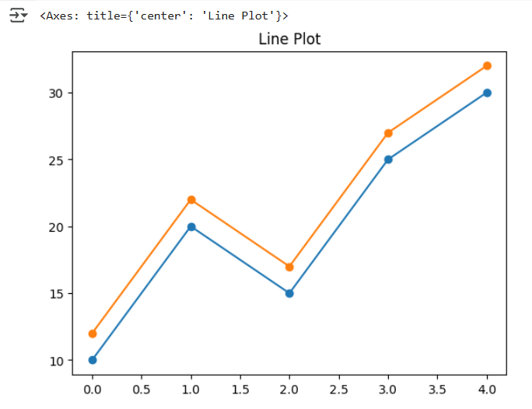

**2. Bar Chart**

**Description:** Displays data as rectangular bars for categorical comparison.  
**Use Case:** Comparing product sales.

**Sample Code:**

df = pd.Series([5, 8, 12], index=['A', 'B', 'C'])

df.plot(kind='bar', title="Bar Chart", color='skyblue')

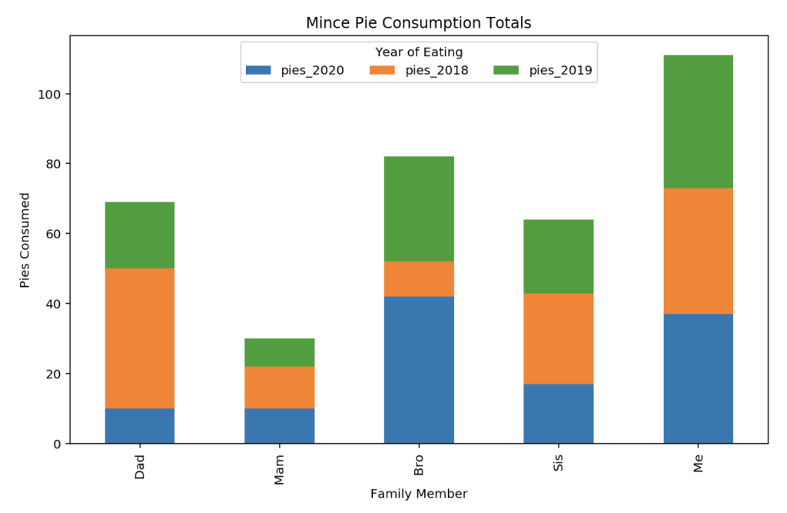

**3. Horizontal Bar Chart**

**Description:** Same as a bar chart but horizontal.  
**Use Case:** Comparing values when category labels are long.

**Sample Code:**

df.plot(kind='barh', title="Horizontal Bar Chart", color='lightgreen')

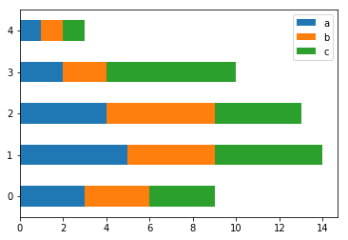

**4. Histogram**

**Description:** Groups numeric data into bins to show frequency distribution.  
**Use Case:** Analyzing exam score distributions

**Sample Code:**

data = pd.Series([3, 5, 5, 6, 7, 8, 8, 9, 10])

data.plot(kind='hist', bins=5, title="Histogram", color='orange', edgecolor='black')

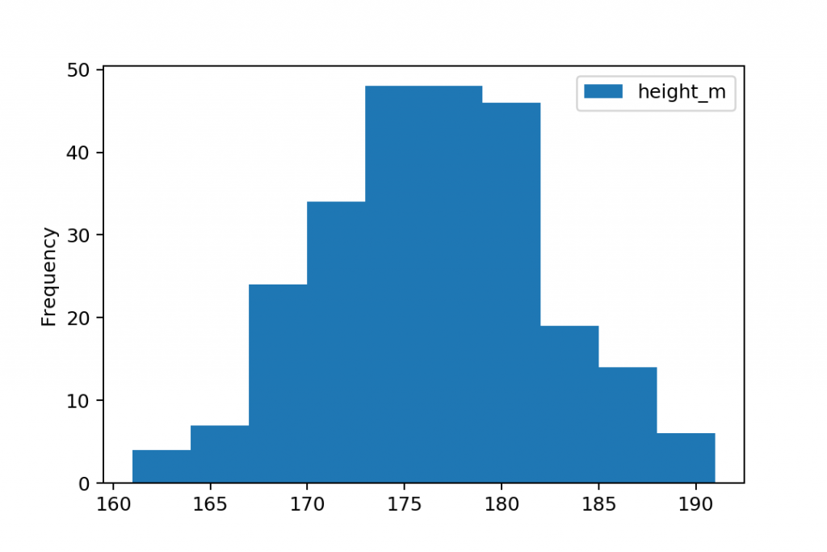

**5. Area Plot**

**Description:** Like a line plot but the area under the line is filled.  
**Use Case:** Showing cumulative trends.

**Sample Code:**

df = pd.DataFrame({

'A': [1, 3, 4],

'B': [2, 4, 6]

})

df.plot(kind='area', alpha=0.5, title="Area Plot")

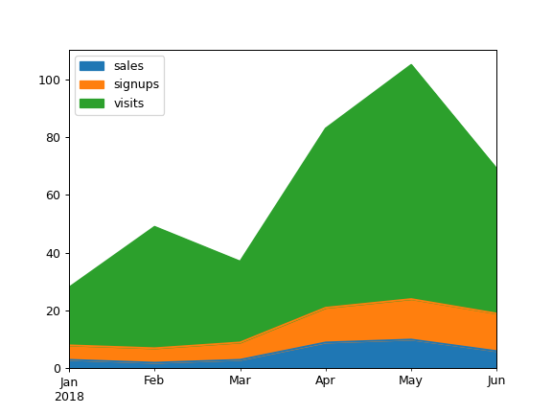

**6. Pie Chart**

**Description:** Shows proportions of a whole as slices of a circle.  
**Use Case:** Visualizing budget distribution.

**Sample Code:**

df = pd.Series([30, 20, 50], index=['A', 'B', 'C'])

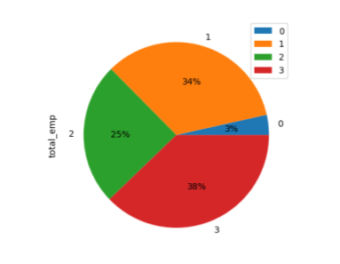df.plot(kind='pie', autopct='%1.1f%%', title="Pie Chart")

**SEABORN**

**Seaborn** is a Python data visualization library built on top of Matplotlib, designed to provide a higher-level interface for creating attractive and informative graphics. Compared to Matplotlib, Seaborn offers advanced built-in features such as improved default styles, color palettes, and simplified syntax, making it easier to generate visually appealing plots with minimal code.

Seaborn supports a wide range of plot types that cater to different data visualization needs, including:

1 Relational Plots:

∙ scatterplot()

∙ lineplot()

∙ relplot()

2 Categorical Plots:

∙ barplot()

∙ countplot()

∙ boxplot()

∙ violinplot()

∙ swarmplot()

∙ pointplot()

∙ catplot()

3 Distribution Plots:

∙ histplot()

∙ kdeplot()

∙ rugplot()

∙ distplot()

4 Relational Plots:

∙ regplot()

∙ lmplot()

5 Matrix Plots:

∙ heatmap()

∙ clustermap()

Here are some sample codes for some of the graphs.

**# Import required libraries**

**import seaborn as sns**

**import matplotlib.pyplot as plt**

**# Load sample datasets**

**tips = sns.load_dataset("tips")**

**flights = sns.load_dataset("flights")**

**iris = sns.load_dataset("iris")**

**# Set Seaborn style**

**sns.set(style="whitegrid")**

**# 1. Scatterplot**

plt.figure(figsize=(6,4))

sns.scatterplot(x="total_bill", y="tip", data=tips, hue="sex", style="time")

plt.title("Scatterplot: Total Bill vs Tip")

plt.show()

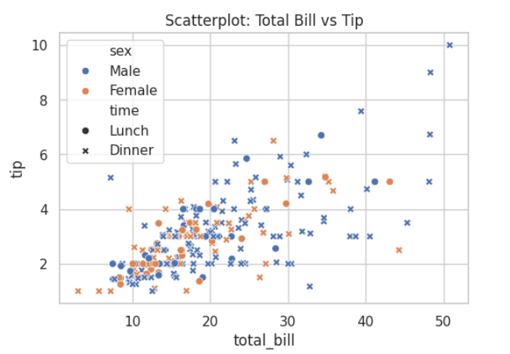

**Description:**scatterplot() plots total_bill on the x-axis and tip on the y-axis.

* The hue="sex" parameter assigns different colors to Male and Female categories.
* The style="time" parameter varies marker shapes based on Lunch/Dinner.
* Each point represents one customer.
* title() adds a title, xlabel() and ylabel() label the axes.
* show() displays the scatterplot.

**# 2. Lineplot**

plt.figure(figsize=(6,4))

sns.lineplot(x="year", y="passengers", data=flights, marker="o")

plt.title("Lineplot: Flights Passengers Over Years")

plt.show()

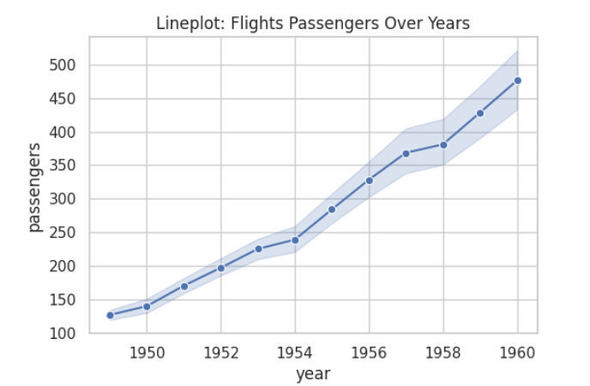

**Description:**  
lineplot() plots year on the x-axis and passengers on the y-axis.

* The line connects points to show trends over time.
* The marker="o" adds circular markers for each data point.
* Useful for visualizing how the number of passengers changes across years.

**# 3. Barplot**

plt.figure(figsize=(6,4))

sns.barplot(x="day", y="total_bill", data=tips, hue="sex")

plt.title("Barplot: Avg Bill by Day & Gender")

plt.show()

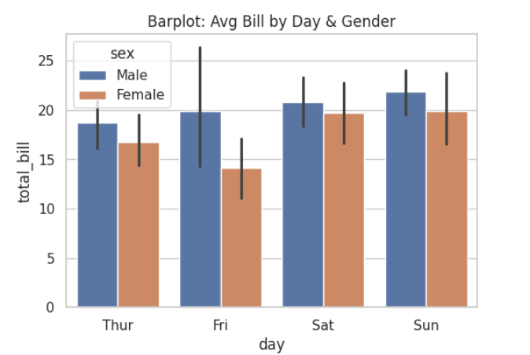

**Description:**barplot() displays the average total bill for each day of the week.

* The hue="sex" parameter splits each bar by Male/Female.
* By default, it shows the mean with confidence intervals.
* Useful for comparing group averages across categories.

**# 4. Countplot**

plt.figure(figsize=(6,4))

sns.countplot(x="day", data=tips, hue="sex")

plt.title("Countplot: Count of Customers by Day & Gender")

plt.show()

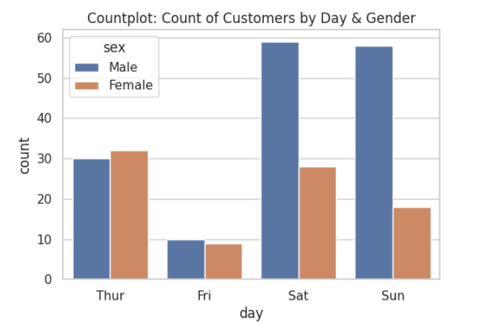

**Description:**countplot() shows the count of observations for each day of the week.

* The hue="sex" parameter splits counts into Male/Female categories.
* Bars represent frequency rather than averages**.**
* Helpful for seeing category distributions.

**# 5. Boxplot**

plt.figure(figsize=(6,4))

sns.boxplot(x="day", y="total_bill", data=tips, hue="sex")

plt.title("Boxplot: Total Bill Distribution by Day & Gender")

plt.show()

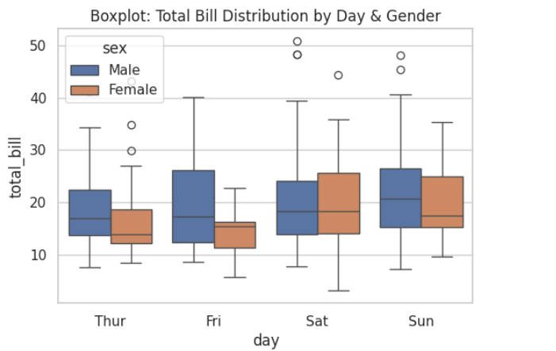

**Description:**boxplot() displays the distribution of total bills for each day.

* The box shows the median, 25th percentile, and 75th percentile.
* Whiskers show variability outside the quartiles.
* Dots represent outliers (very high/low bills).
* The hue="sex" parameter allows Male/Female comparison.

**# 6. Histogram (Histplot)**

plt.figure(figsize=(6,4))

sns.histplot(tips["total_bill"], bins=20, kde=False, color="skyblue")

plt.title("Histogram: Distribution of Total Bill")

plt.show()

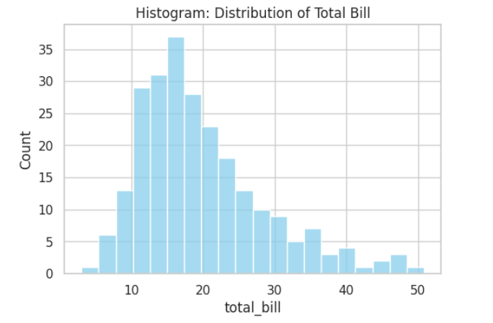

**Description:**histplot() shows the frequency distribution of total bills.

* The bins=20 parameter controls the number of intervals.
* The kde=False hides the kernel density line (can be enabled if needed).
* The color parameter sets bar color.
* Useful for understanding distribution shape and spread.

**# 7. KDE Plot**

plt.figure(figsize=(6,4))

sns.kdeplot(tips["total_bill"], shade=True, color="red")

plt.title("KDE Plot: Density of Total Bill")

plt.show()

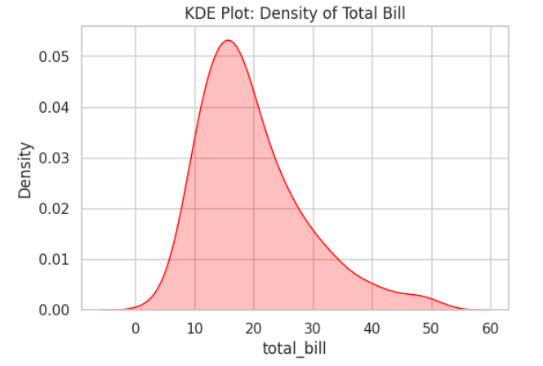

**Description:**kdeplot() displays the Kernel Density Estimation for total_bill.

* The shade=True parameter fills the area under the curve.
* The curve represents a smoothed version of the histogram.
* Useful for identifying peaks and overall distribution shape.

**# 8. Heatmap**

plt.figure(figsize=(6,4))

corr = iris.select_dtypes(include=["float64", "int64"]).corr()  # Only numeric columns

sns.heatmap(corr, annot=True, cmap="coolwarm", linewidths=0.5)

plt.title("Heatmap: Correlation Matrix (Iris Dataset)")

plt.show()

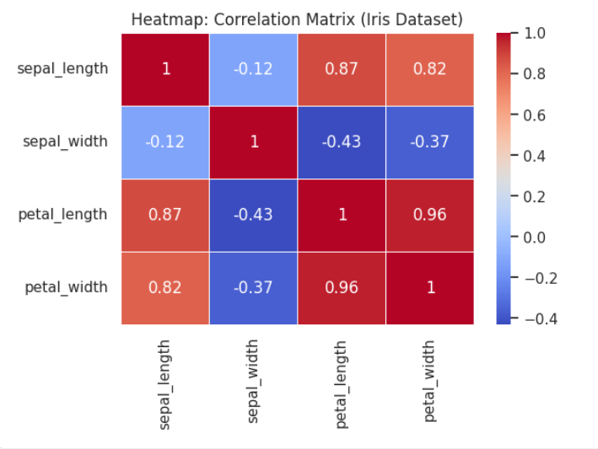

**Description:**heatmap() visualizes the correlation matrix of numeric columns in the Iris dataset.

* annot=True displays correlation values inside cells.
* cmap="coolwarm" applies a blue-to-red color gradient.
* linewidths=0.5 adds spacing between cells.
* Darker colors indicate stronger positive/negative correlations.

**# 9. Regression Plot**

plt.figure(figsize=(6,4))

sns.regplot(x="total_bill", y="tip", data=tips, scatter_kws={"alpha":0.5}, line_kws={"color":"red"})

plt.title("Regression Plot: Total Bill vs Tip")

plt.show()

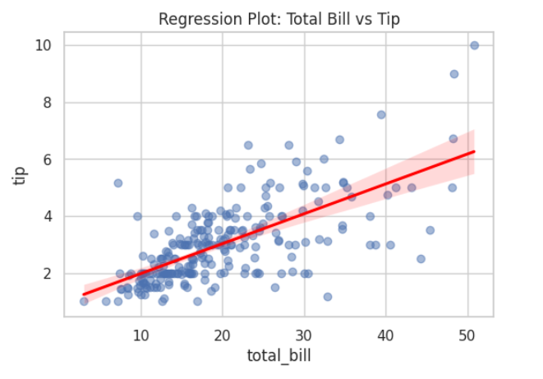

**Description:**regplot() shows the relationship between total bill and tip with a regression line.

* scatter_kws={"alpha":0.5} makes points semi-transparent.
* line_kws={"color":"red"} customizes the regression line color.
* Useful for analyzing linear trends and correlation strength between variables.

**COMPARISON OF PANDAS AND SEABORN**

**• Purpose**

* **Pandas →** Mainly for data manipulation with some basic visualization.
* **Seaborn →** Mainly for data visualization with advanced statistical plots.

**• Plotting Capability**

* **Pandas →** Limited to basic plots (.plot() for line, bar, histogram, scatter).
* **Seaborn →** Offers a wide variety (scatter, line, bar, box, KDE, heatmap, regression, etc.).

**• Customization**

* **Pandas →** Customization needs extra work with Matplotlib**.**
* **Seaborn** → Provides beautiful defaults (colors, styles, palettes) with less effort.

**• Ease of Use**

* **Pandas →** Quick plots for fast exploratory checks.
* **Seaborn →** Better for presentation-ready visuals and detailed analysis.

**• Integration**

* **Pandas →** Works seamlessly with NumPy, Seaborn, Matplotlib.
* **Seaborn →** Built on Matplotlib, works smoothly with Pandas DataFrames.

**CONCLUSION:**

Both Pandas are essential tools in Python’s data visualization ecosystem, each serving different needs.  
For **in-depth, highly customized visuals** → use **Seaborn**.For **fast, simple visualizations during analysis** → use **Pandas**.

Bottom of Form